DSA0502 – QUERY PROCESSING FOR DATA SCIENCE
LAB PROGRAMS
NAME: B KIRTHANAA REG. NO – 192324244

9. Write a Pandas program to create a Pivot table and find the total sale amount region wise, manager wise, sales man wise.
Aim:
To create a Pivot Table using Pandas and find the total sales amount region-wise, manager-wise, and salesman-wise.

CODE:
import pandas as pd
# Create dataset
data = {
"Region": ["North", "North", "South", "South", "East", "East"],
"Manager": ["John", "John", "David", "David", "Peter", "Peter"],
"Salesman": ["Ram", "Ravi", "Anu", "Priya", "Kiran", "Meena"],
"Sales": [5000, 7000, 6000, 8000, 4000, 9000]
}
df = pd.DataFrame(data)

# Pivot Table
pivot = pd.pivot_table(df,
values="Sales",
index=["Region", "Manager", "Salesman"],
aggfunc="sum")

print(pivot)

OUTPUT:
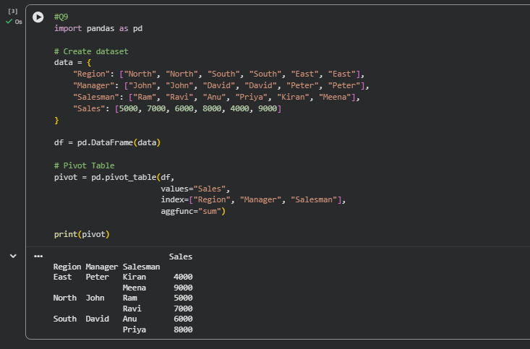
10. Create a DataFrame of ten rows and four columns with random values. Highlight the negative numbers in red and positive numbers in black.
Aim:
To create a DataFrame with random values and highlight negative numbers in red and positive numbers in black using Pandas Styling.
CODE:
import pandas as pd
import numpy as np

df = pd.DataFrame(np.random.randint(-10, 10, (10,4)))

def color(x):
if x < 0:
return "color:red"
return "color:black"

df.style.map(color)
OUTPUT:
